_A_d_m it_C a_rd f_o_r_W ri_tt_e_n E_x_a_m_i_n_a_t_io_n_

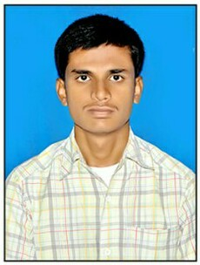Application Number : 2017018756
Name of the Post : Technical Officer (IT) Name of the applicant : dande upendra
Date : Friday April 14, 2017 Time of Examination : 10.00 AM - 12.00 PM Reporting Time : 9.00 AM
Venue : IISER Tirupati
Transit Campus :
Sree Rama Engg College Mangalam, Karakambadi Road Tirupati, Andhra Pradesh
India PIN:517507 Signature of the candidate

Sd/- Registrar

